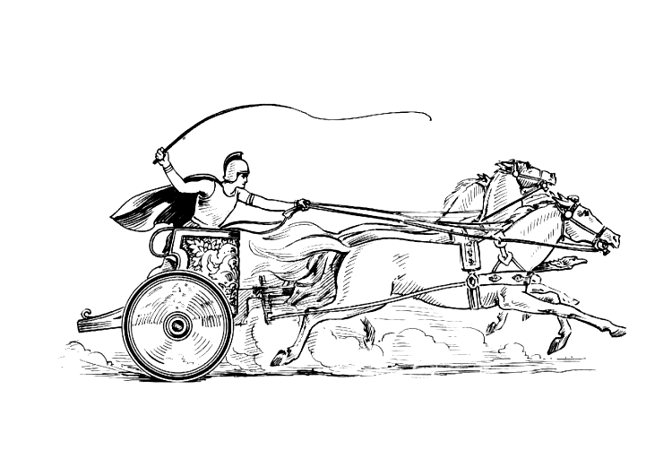Manduessedum - Mancetter Village (Place of War Chariots)
Mancetter Parish Council
Serving the People of Mancetter and Ridge Lane

You are invited to an Extraordinary Parish Council Meeting
to be held in the Schoolroom of St Peter’s Church Mancetter
on Thursday 22nd June 2023 at 7pm.

AGENDA

- Welcome and Apologies.
- Chairman’s request that anyone recording the meeting make themselves known, to allow
openness and recognise practicalities.

- Declared Notice of Interest by Councillors concerning Agenda items.
- Public Question time of up to 15 Minutes for Parishioners to raise issues.

- Formal receipt of the accounts for 2022/2023.
- Formal signing of section one of the Annual Governance and Accountability Return for
the year 2022/23 – Annual Governance Statement.
- Formal signing of section two of the Annual Governance and Accountability Return for
the year 2022/23 – Accounting Statements.

- To update the Parish Council Bank Mandate.
- To review amendments to planning application PAP/2022/506 Canal Cottage Quarry
Lane Mancetter.

- Exclusion of the Public and Press To consider whether, in accordance with Section 100A(4) of the Local Government Act 1972, the public and press be excluded from the meeting for the following items of business, on the grounds that they involve the likely disclosure of exempt information as defined by Schedule 12 A to the Act.

- Update on public liability insurance claim in relation to the tree on Mancetter Green.

11 Date of next meeting- Tuesday 25th July 2023 7PM AT ST PETERS CHURCH SCHOOLROOM

Signed E. L. Higgins
Date 19th June 2023.
Elane Higgins
Parish Clerk Mancetter Memorial Hall Old Farm Road Mancetter CV9 1QN Tel: 01827 722552 / 07368 265051Email: parishclerk@mancetter.org.uk Website: www.mancetter.org.uk

